Parking Information for First Presbyterian of Kirkwood

First Presbyterian of Kirkwood is located off of Kirkwood Avenue and Adams Street. There are multiple entrances into the building, but minimal parking options compared to the past due to what’s owned by the City of Kirkwood now.

The main parking lot can be found off of Kirkwood and Adams. If you park in the accessible parking in that lot, your closest accessible entrance is a red door marked with “Accessible Entrance” signs and will take you directly into a room off the front of the sanctuary. Please see the picture below.

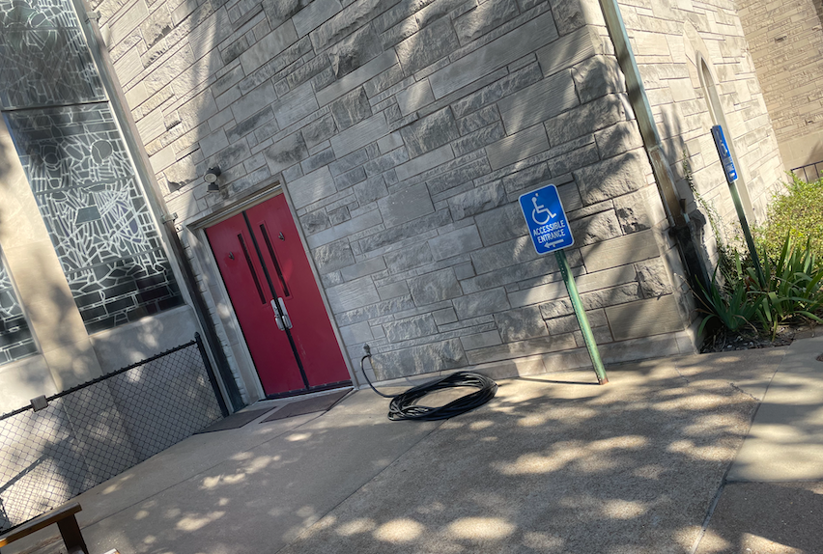

Entrances into First Presbyterian of Kirkwood, and restroom/changing stall information

There’s also a corner entrance from that parking lot that only has stairs.

If you walk from that parking lot (facing the church, go to the right), the doors you’ll find are the North “Main” entrance. There’s a ramp, stairs, and double door entry with push button access.

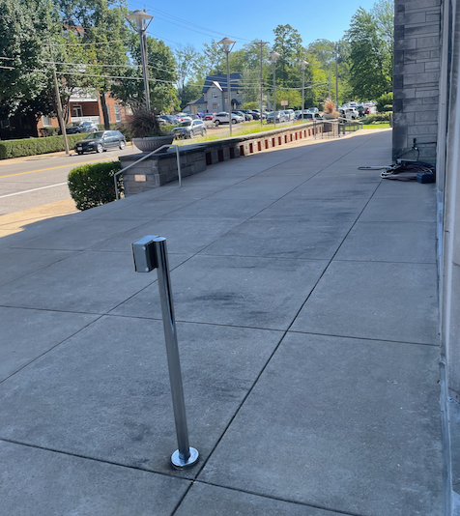

If you walk from that parking lot (facing the church, go to the left) you’ll go up a small set of stairs and follow a path to the South entrance, which has a ramp, push button and stairs available.

When you enter the church, look for the circular kiosk- restrooms will be to the left of the kiosk (if coming from main entrance) or to the right if coming from South entrance.

In FPoK, there is one accessible stall in each restroom. Changing stations are outside of the accessible stalls. All restrooms have an accessible water fountain by them.
